**Name:** Omar Ahmed Mohamed Ahmed Saleh.

**B.N:** 1139.

**Topic:** Computer architecture.

**Date:** 23/5/2020.

**Github account:**

**Date**

* **Topic brief**:

**Computer architecture**

* The computer is of great importance in our daily life, so there is no work or place where the computer is not used in our time, and its importance lies in its simplification of many difficult works that need a long time to complete, such as industrial and commercial works, government departments, universities and institutes, as it is a method with a high ability to solve digital issues and accuracy in preserving and retrieving information and designing Documentation, photos, information searches and collecting device.
* The computer has become an effective and important role for human life, as there are many advantages and benefits that arise from its use (Entertainment, communication with others, organization of work, internet connection and accuracy in carrying out tasks).
* **Computer:** It is an electronic device that has the ability to receive data and process it into valuable information that it stores in different storage media and is often able to exchange this information and results with other compatible devices.
* **Computer components are divided into two parts:**

1. Hardware components.
2. Software components.

* **The Hardware components is divided into two parts:**

1. Internal components such (CPU-Hard drive-RAM).
2. External components such (Mouse-Keyboard-Monitor).

* **The software components is divided into two parts:**

1. System software such (Windows-DOS programs).
2. Application software(Google chrome-Internet download manager).

**Screen shots of (HTML)**

* 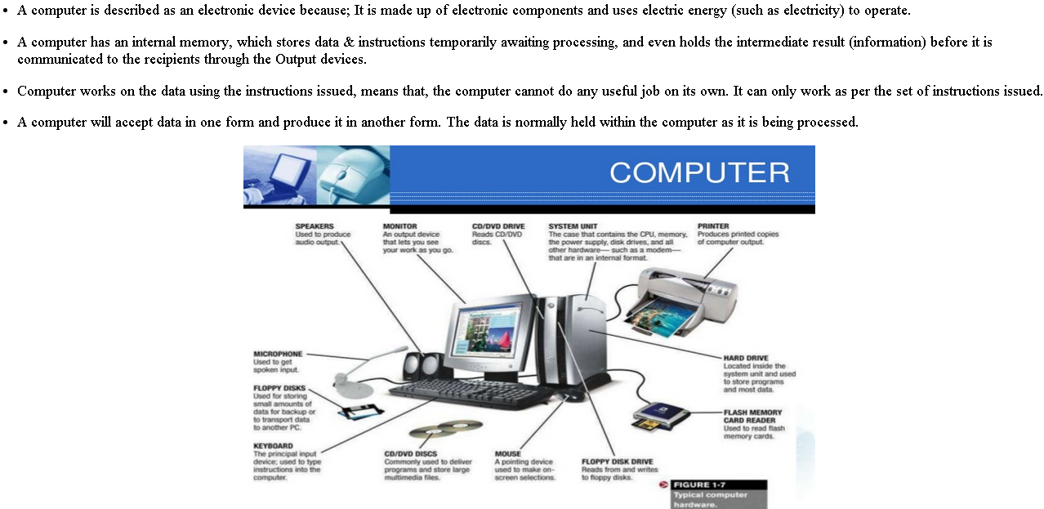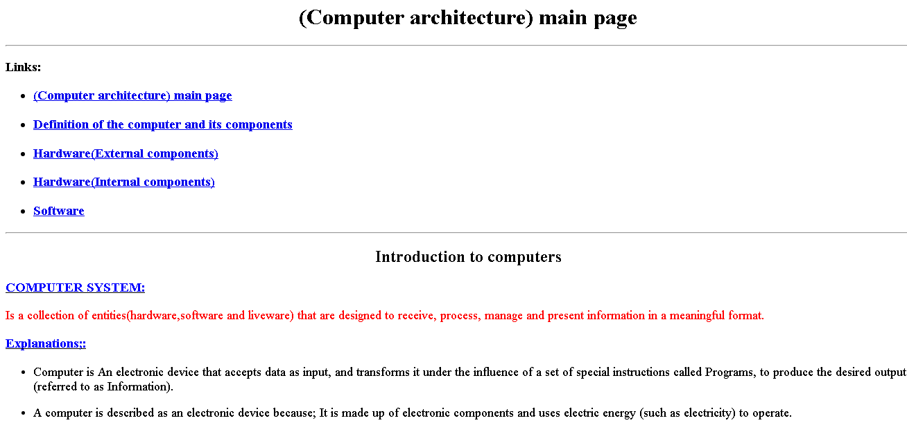**Main page:**
* 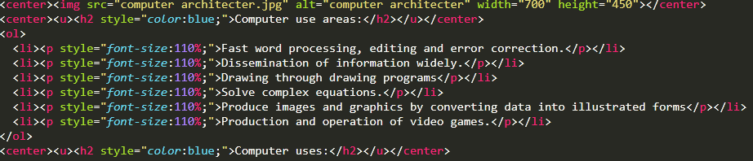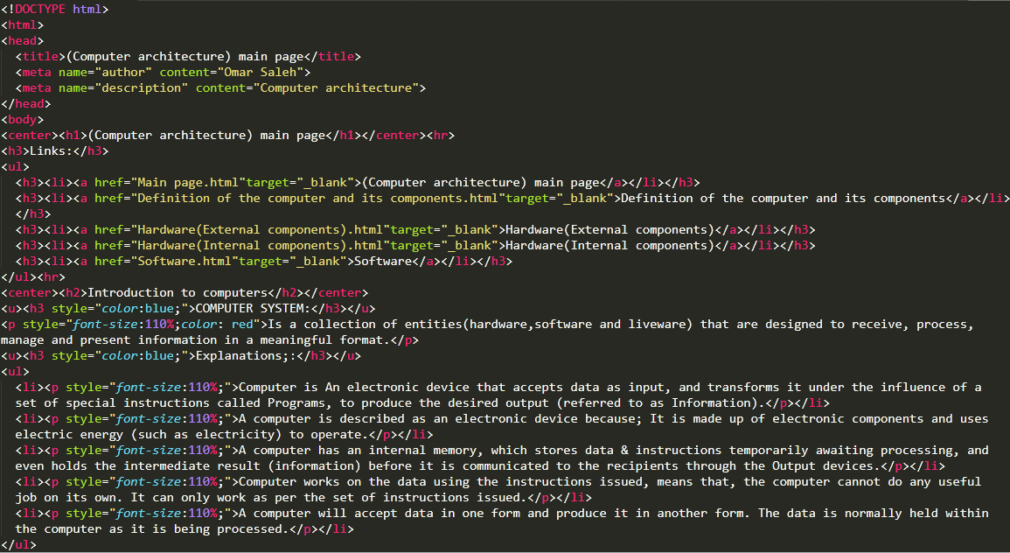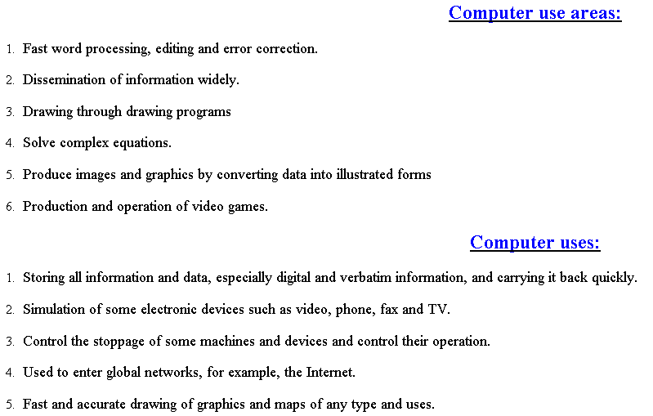**Main page source code:**
* 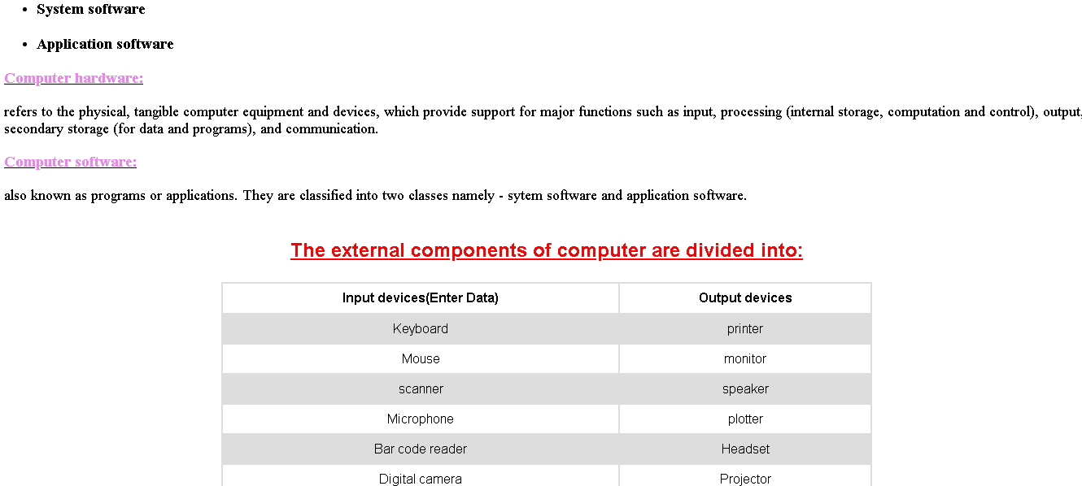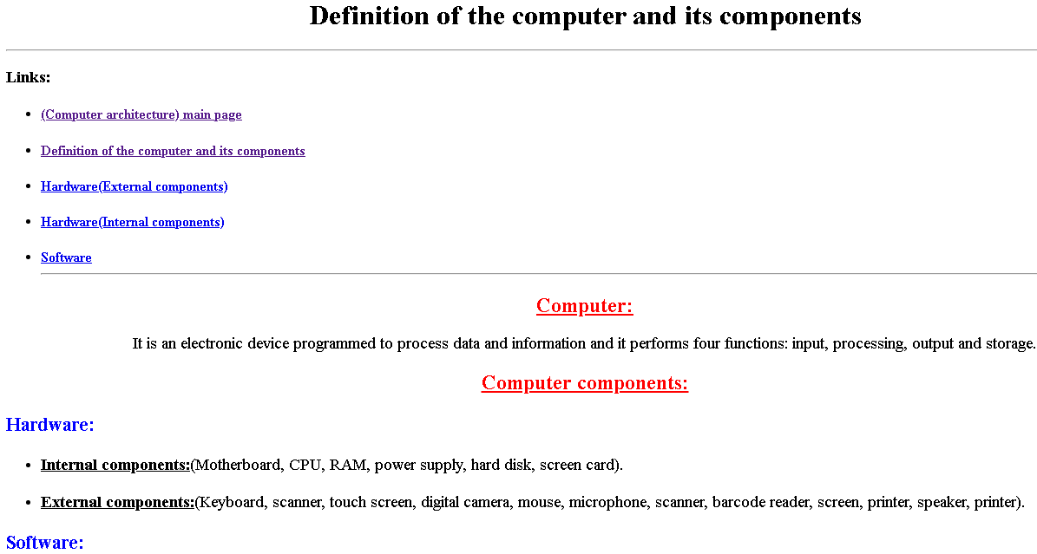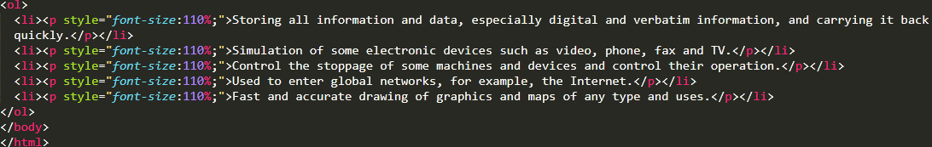**Page (1):**
* 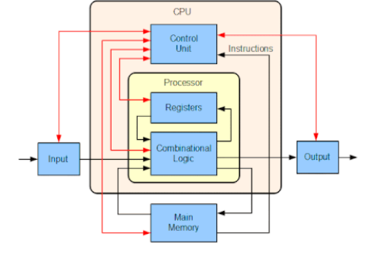**Page(1)source code:**

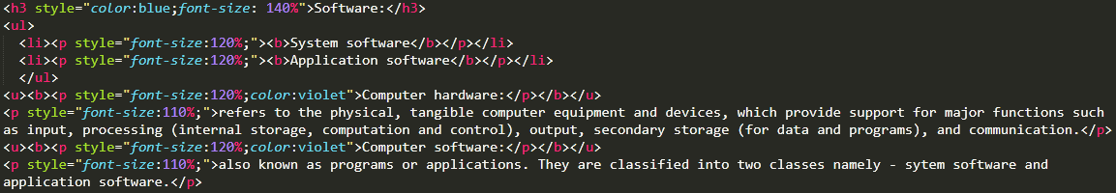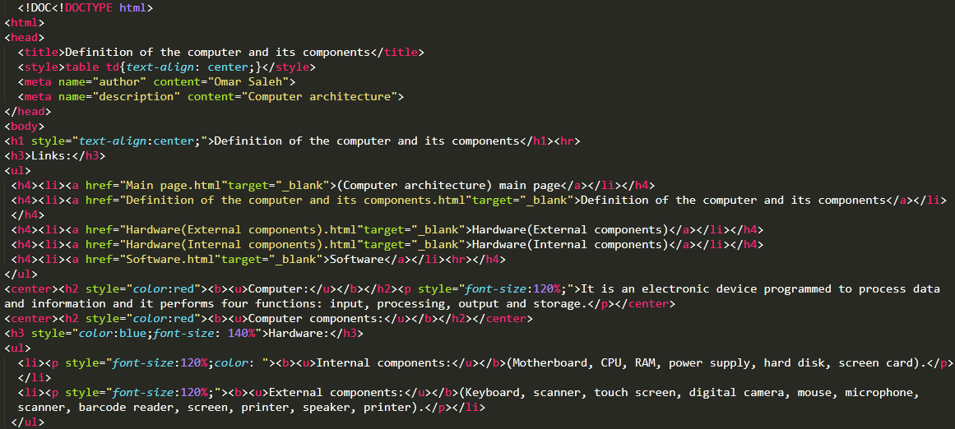

* 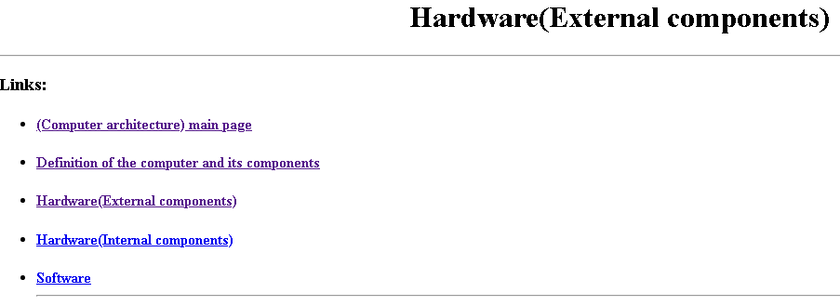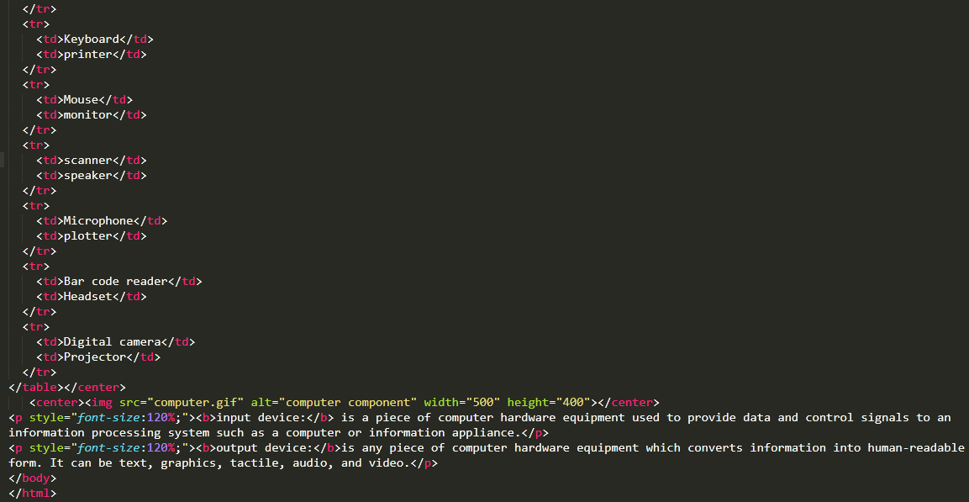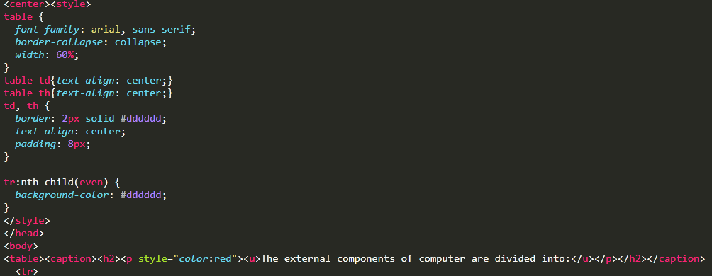**Page(2)**:

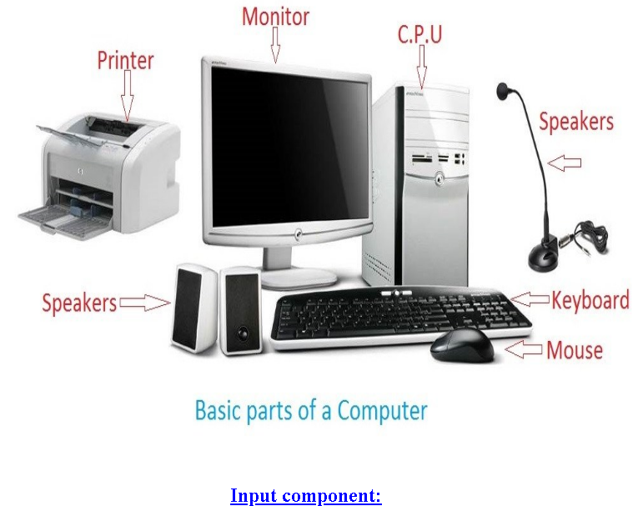

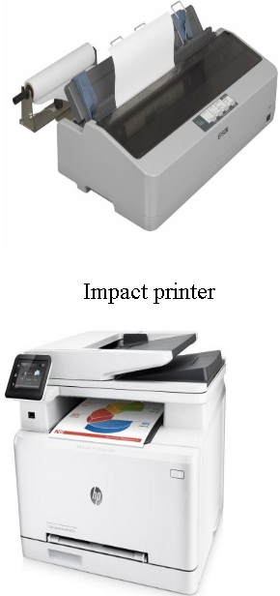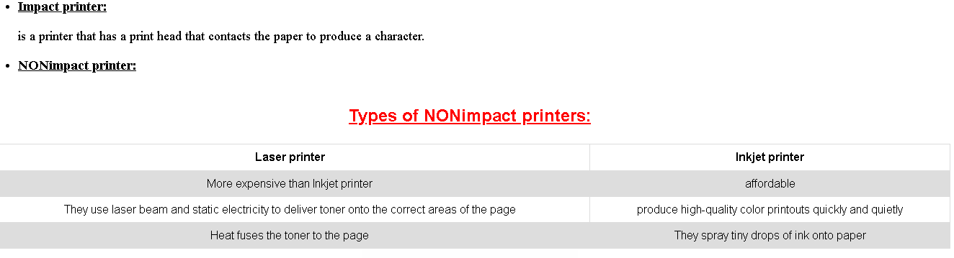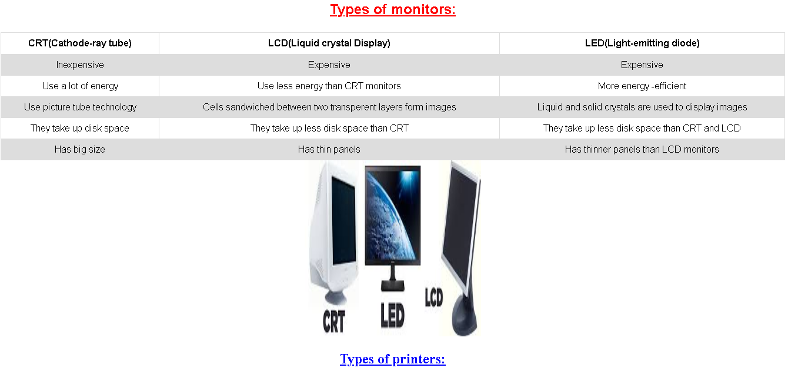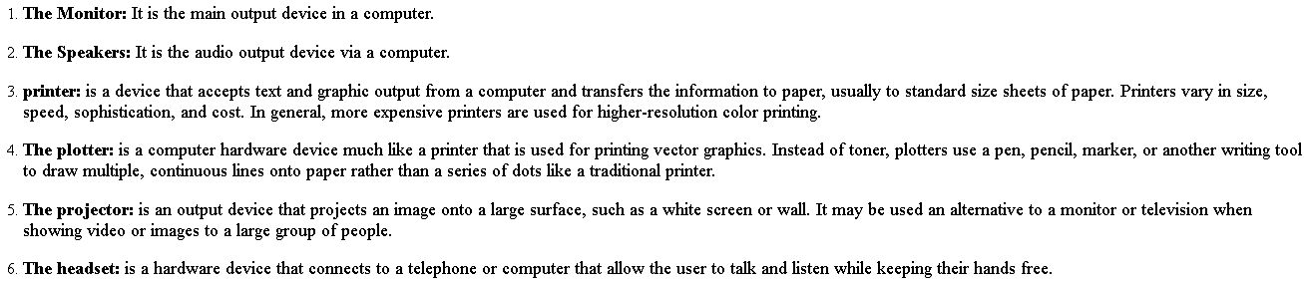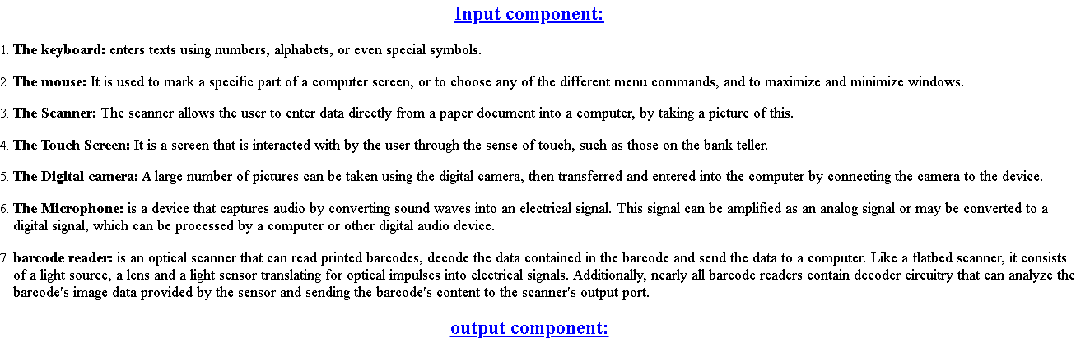

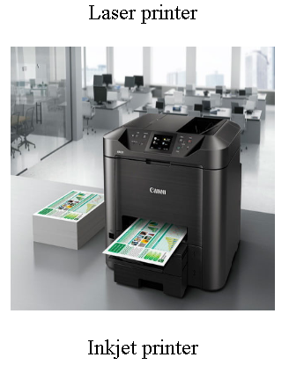

* 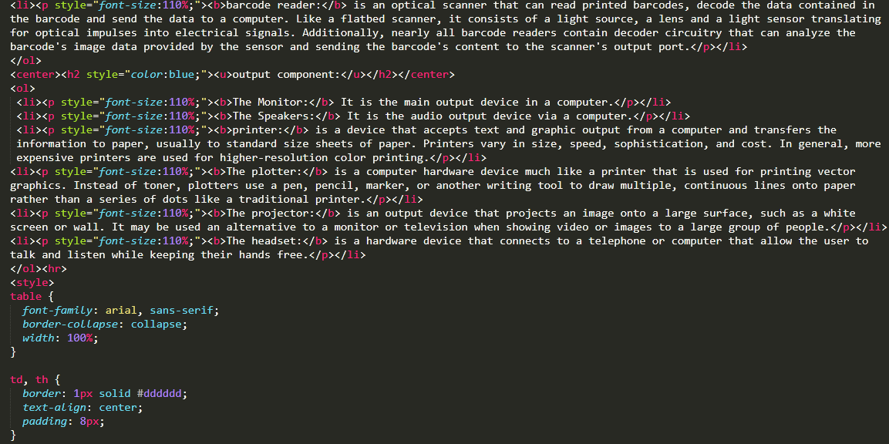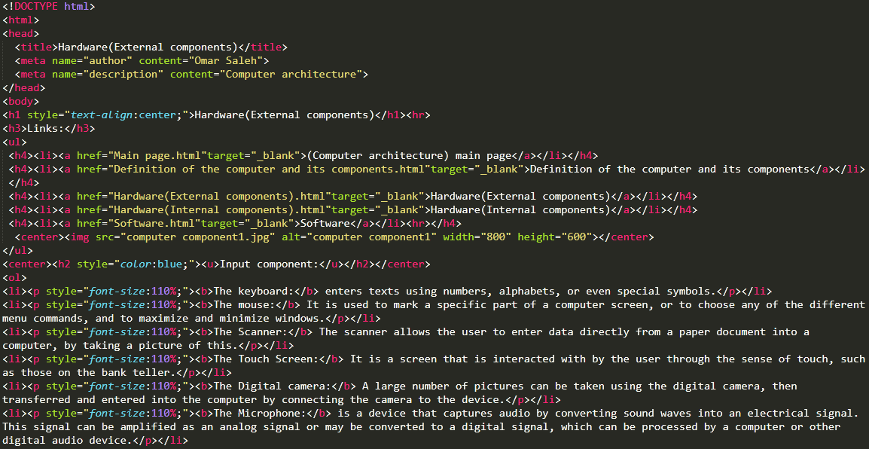**Page(2)source code:**
* **Page(3)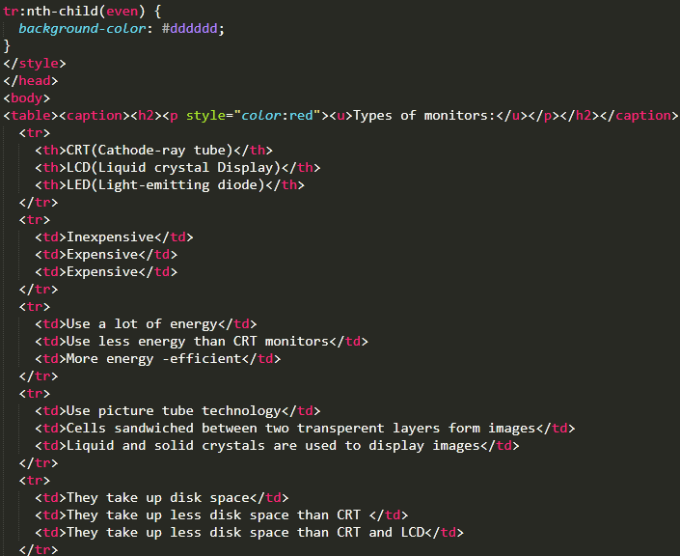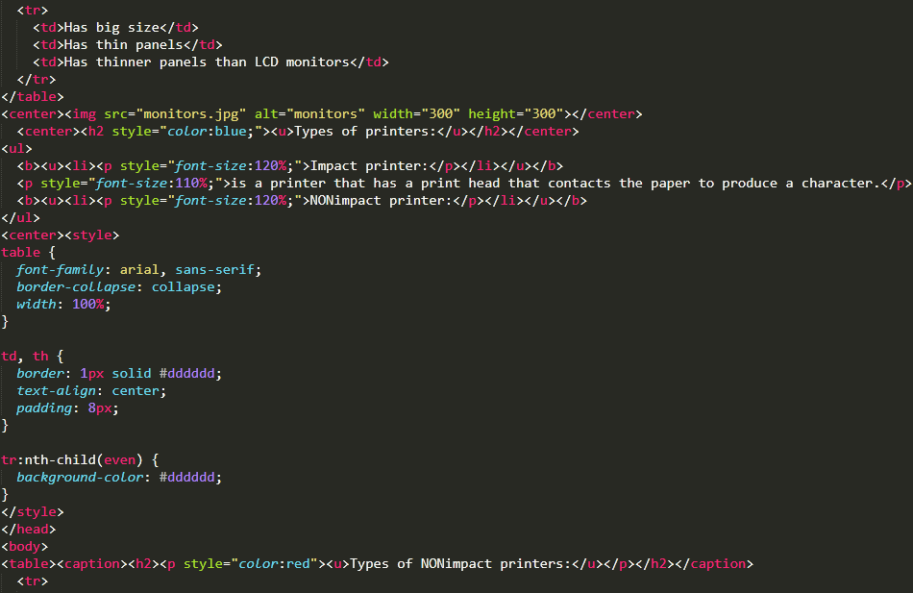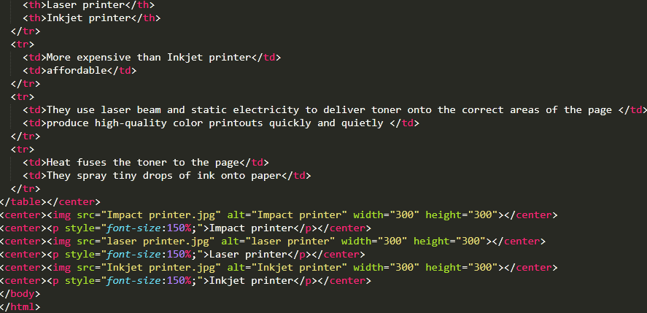:**

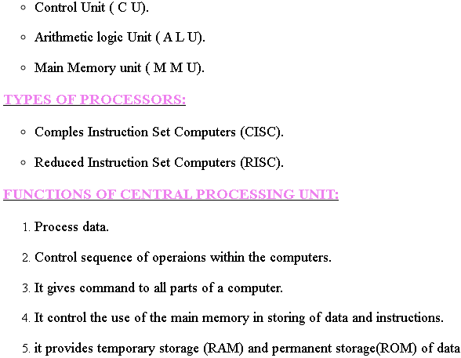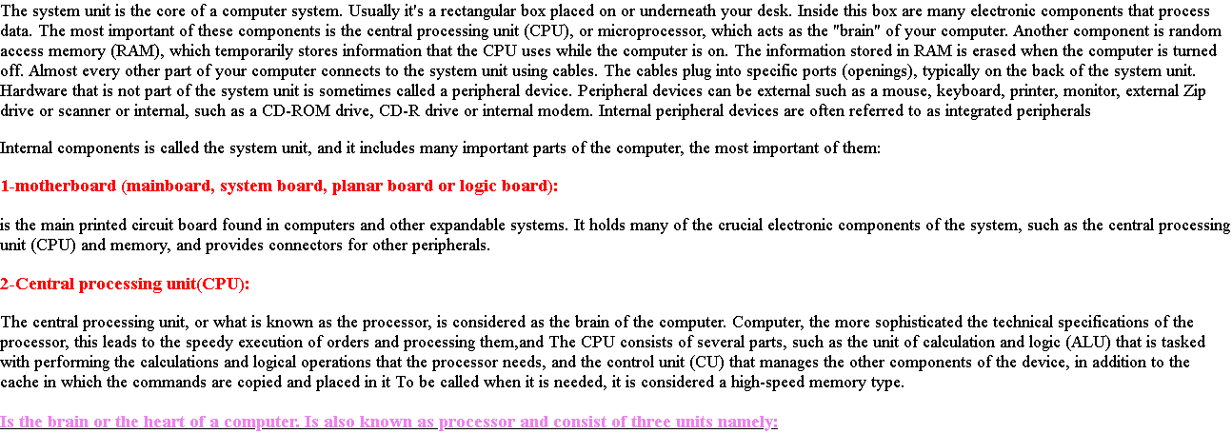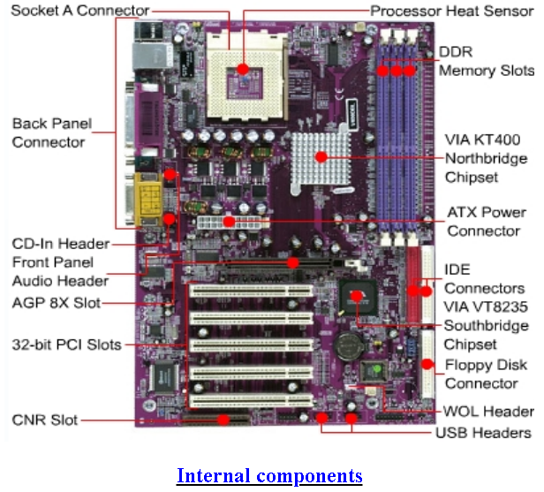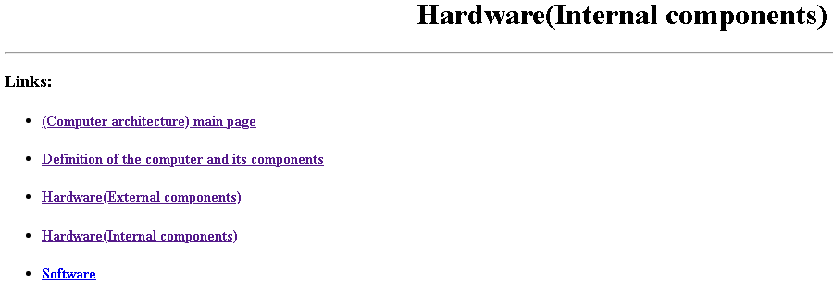

* **Page(3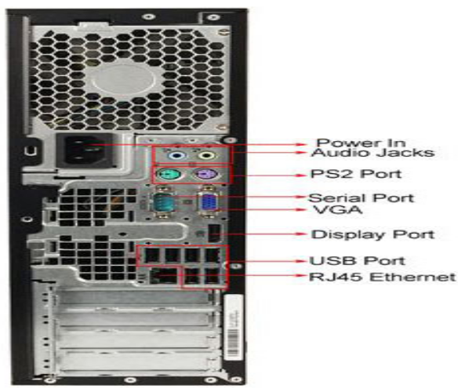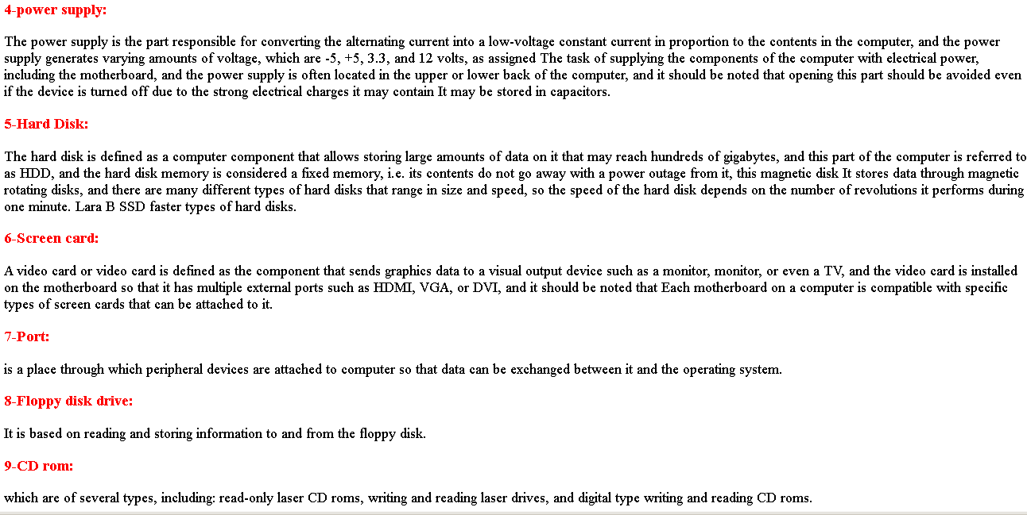)source code:**

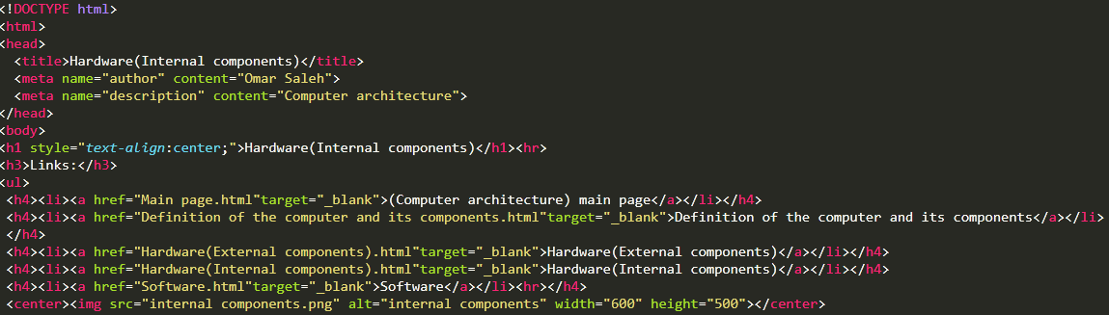

* **Page(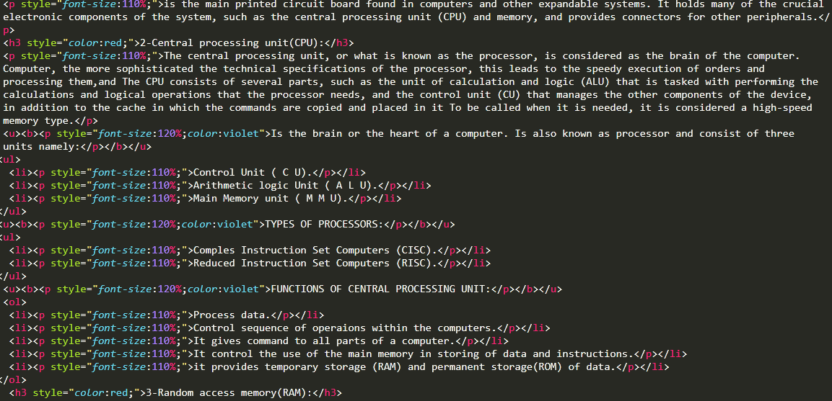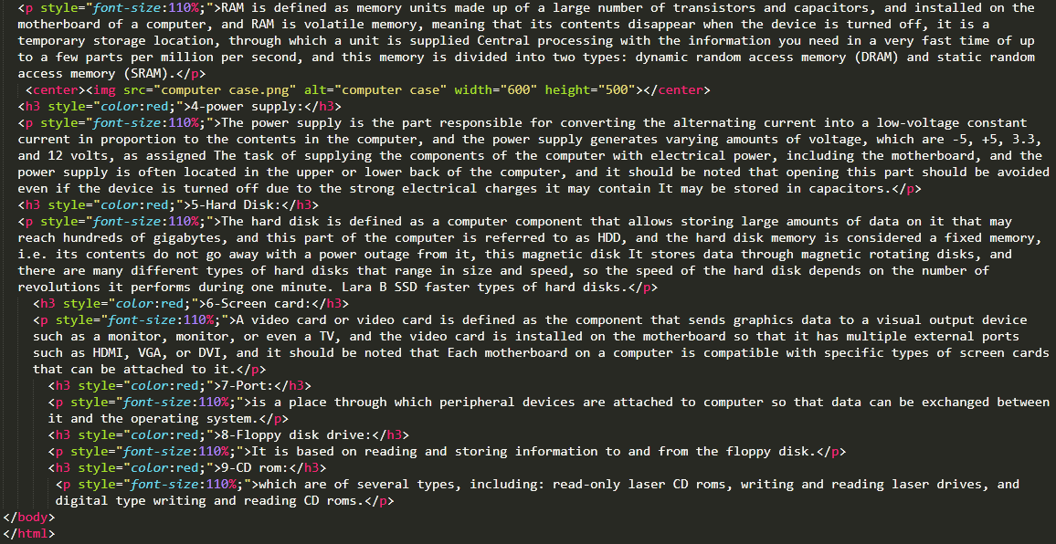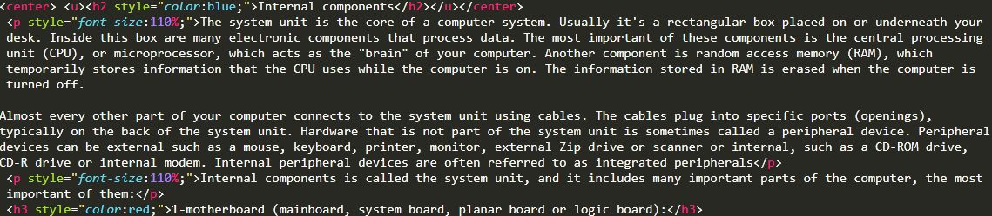4):**

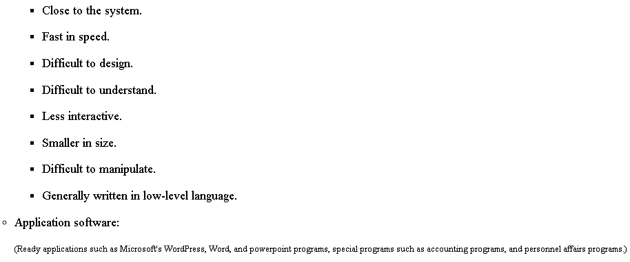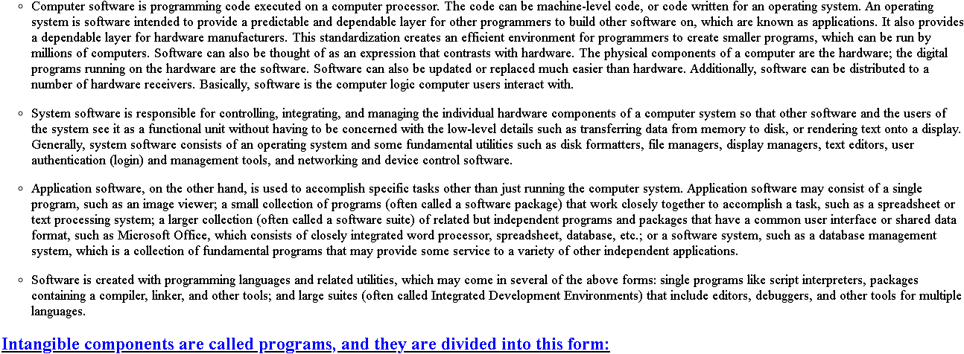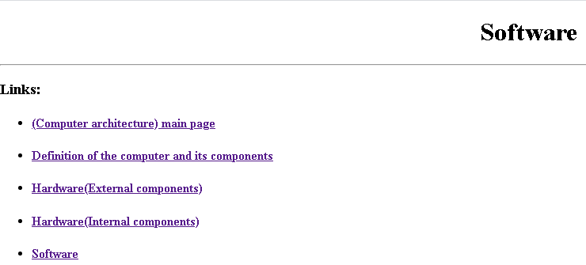

* **Page(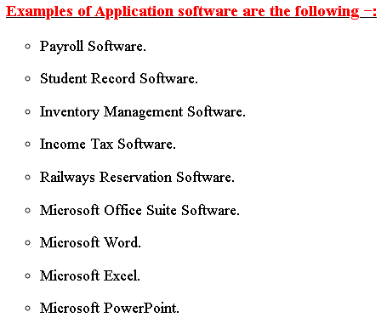4)source code:**

